Now I used attach/detach partitioning in the code but 2-3 month period was not enough for my data. In the where clause I filtered data with current_data-6 month and current_data that’s because my max event_date was 2024-12-31 and I had to insert some data before that. And because current_dates value change over the time when we run this code after 3 month data will be also inserted in 2025 years partitioned table. that’s why I used it.

Data inserted in main fact table:

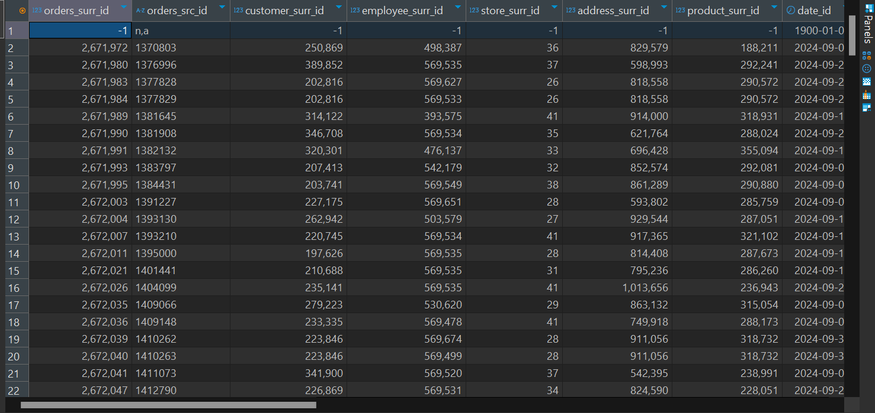

Data inserted in the partitions:

Historical partition data: 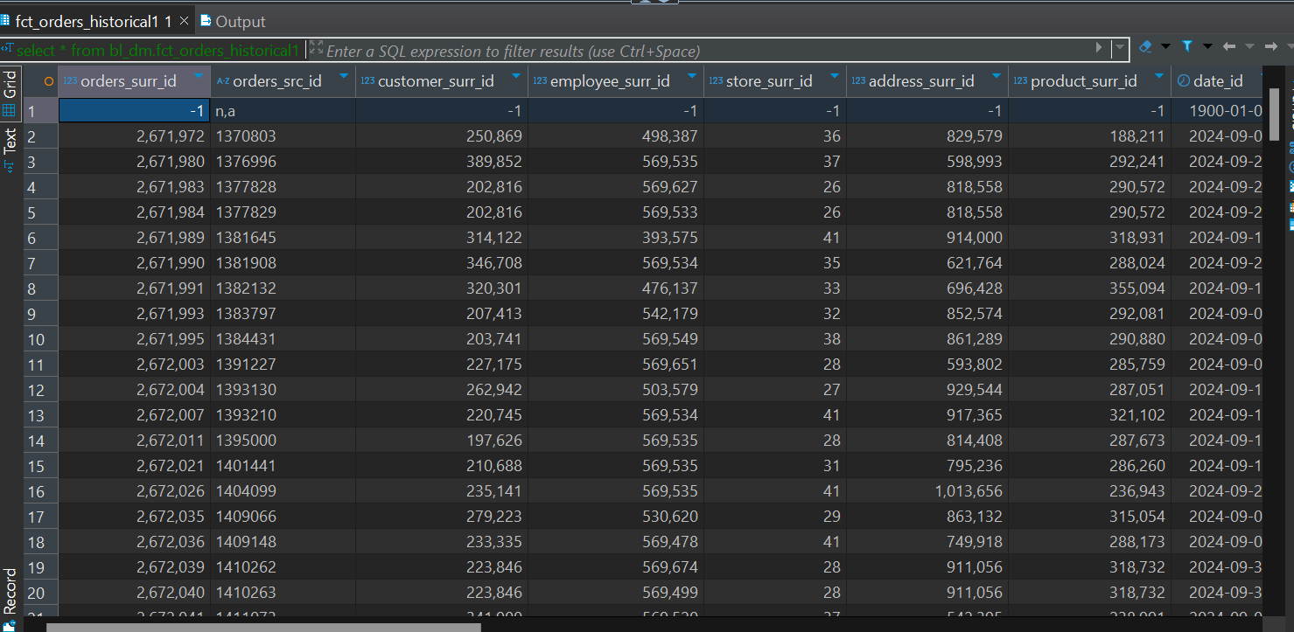

bl_dm.fct_orders_2024_10 data:

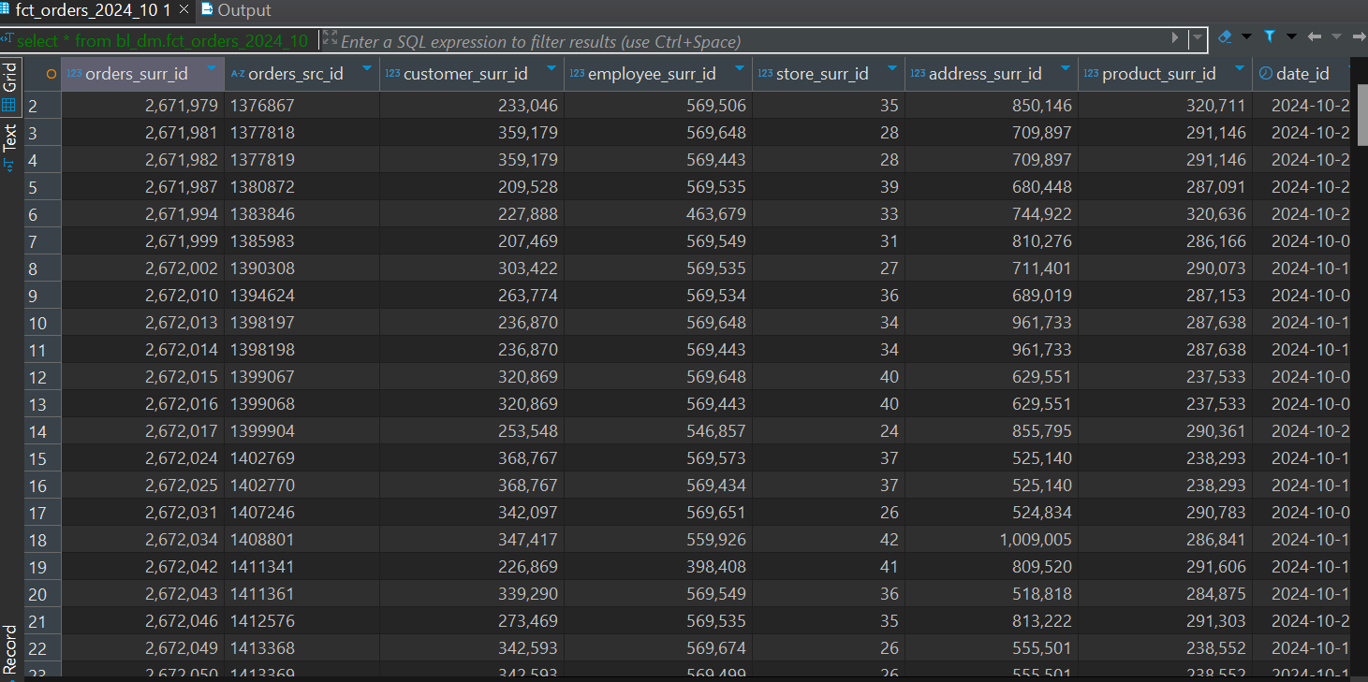

bl_dm.fct_orders_2024_11 data:

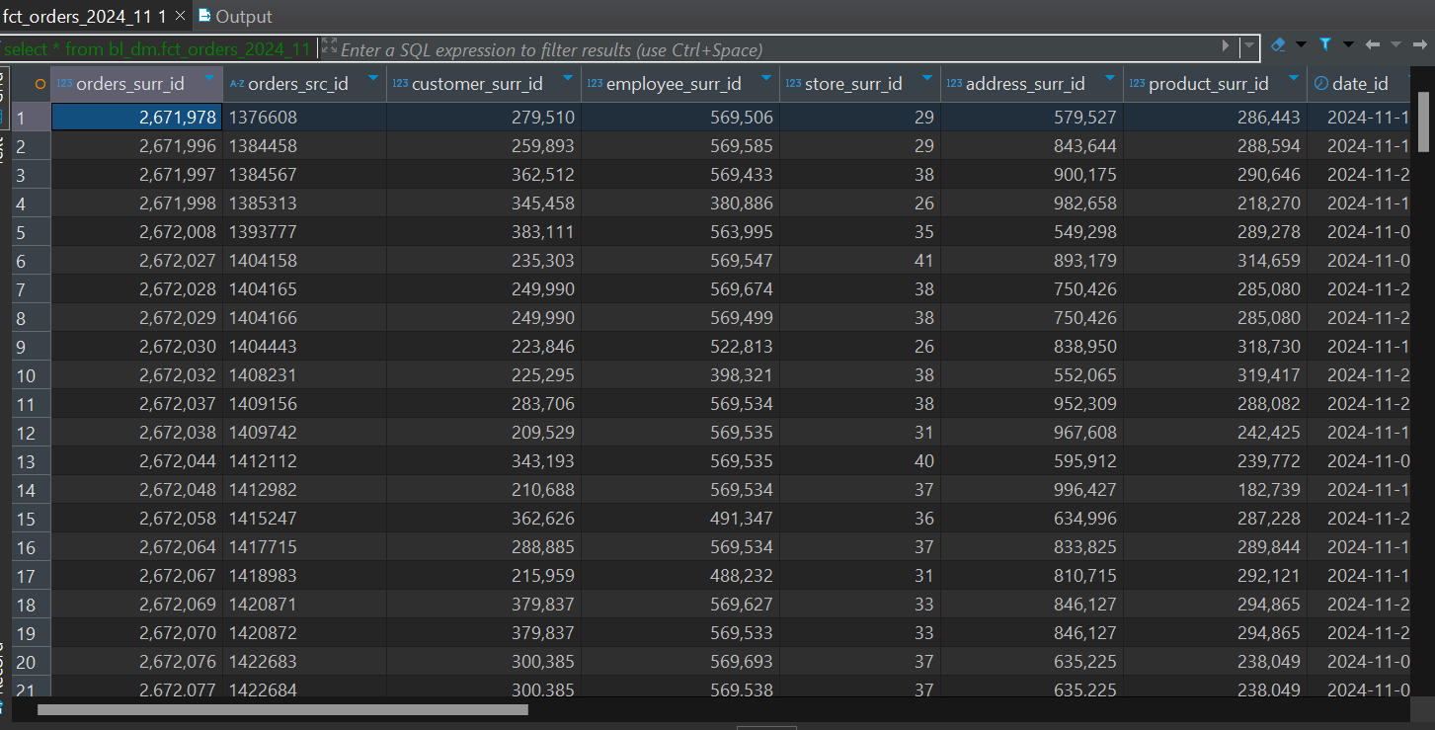

bl_dm.fct_orders_2024_12 data:

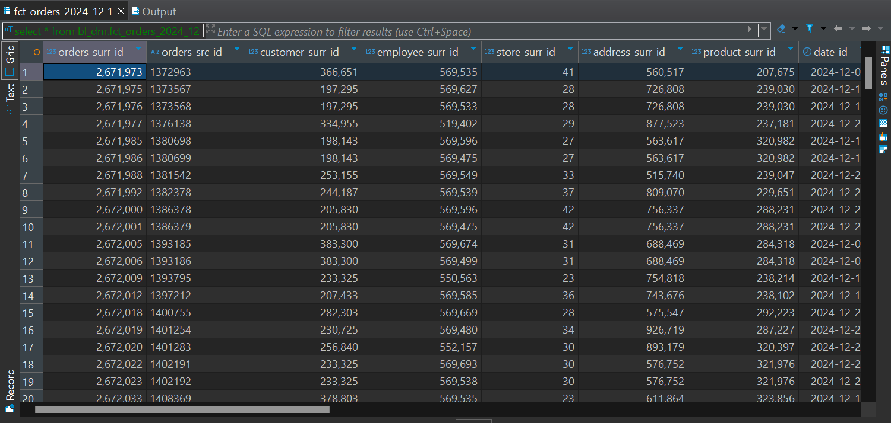

And since my max event_date is 2024-12-31 nothing Is inserted in 2025 partition.

And also I want to say something about incremental loading in my 3nf fact table.as I understand incremental loading is the process when we insert data in the table based on some condition,for example last_update>’2024-11-31’ and if my understanding is correct I’m also using incremental loading process in the 3nf fact table. I insert data based on if event_date is greater than ‘2023-01-01’ or not. So I hope it counts as a incremental loading.

Data in my 3nf fact table:

